Astronomical magnitudes

Magnitudes tell us how bright an object in the sky appears. Objects can be bright either because they emit a lot of light or because they are close to us.

Brighter objects have more negative magnitudes. This seems opposite to intuition – blame Ptolemy and Ancient Greece for this system!!

Magnitudes are expressed on a logarithmic scale, so that each one-unit change in magnitude is a factor of 2.5 change in brightness.

For example the star Polaris (magnitude 1.9) is brighter than the star Vega (magnitude +0.03) by approximately a factor of 6 (2.5^{1.9}).

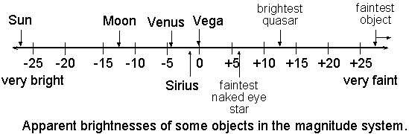

Astronomical distances

Scientists use big units to describe big distances. Two common units are the:

- astronomical unit (AU) = average distance from earth to sun
- lightyear (ly) = distance light travels in one year

Here’s how to convert some common abbreviations:

Kly = 1,000 ly
Mly =1,000,000 ly
Gly = 1,000,000,000 ly

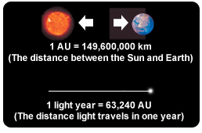

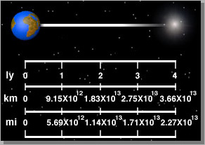

Planetary nebulae

A planetary nebula consists of an expanding glowing shell of ionized gas ejected from old red giant stars late in their lives. The word 'nebula' is Latin for mist or cloud and the term 'planetary nebula' is a misnomer that originated in the 1780s with astronomer William Herschel because when viewed through his telescope, these objects appeared to him to be newly forming planetary systems. They are a relatively short-lived phenomenon, lasting a few tens of thousands of years, compared to a typical stellar lifetime of several billion years.

A mechanism for formation of most planetary nebulae is thought to be the following: at the end of the star's life, during the red giant phase, the outer layers of the star are expelled via pulsations and strong stellar winds. The exposed hot, luminous core emits ultraviolet radiation that ionizes the ejected outer layers of the star. This energized shell of nebulous gas reradiates the absorbed ultraviolet energy at visible frequencies and appears as a planetary nebula.

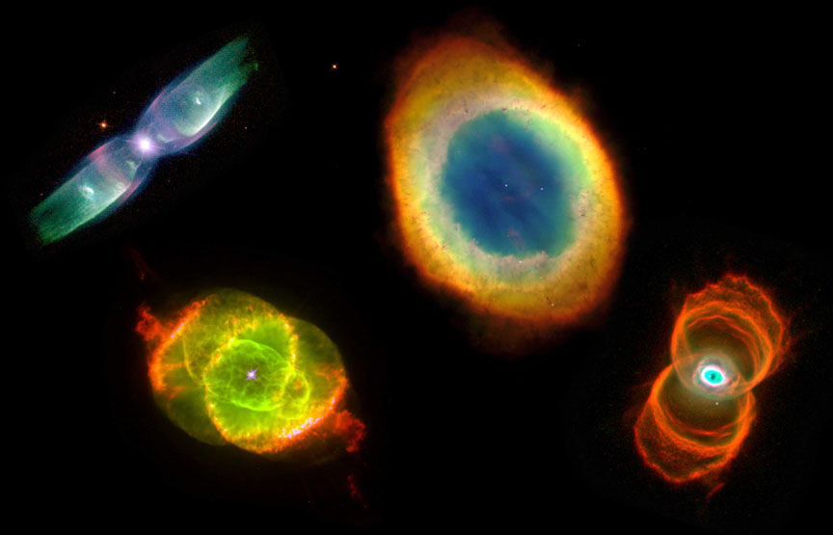

Galaxy

A galaxy is a massive, gravitationally bound system consisting of stars, stellar remnants, an interstellar medium of gas and dust, and dark matter. The word galaxy is derived from the Greek galaxias, literally "milky", a reference to the Milky Way. Examples of galaxies range from dwarfs with as few as ten million stars to giants with one hundred trillion stars, each orbiting their galaxy's own center of mass.

Galaxies contain varying numbers of planets, star systems, star clusters and types of interstellar clouds. In between these objects is a sparse interstellar medium of gas, dust, and cosmic rays. Supermassive black holes reside at the center of most galaxies.

A common form is the elliptical galaxy, which has an ellipse-shaped light profile. Spiral galaxies are disk-shaped with dusty, curving arms. Those with irregular or unusual shapes are known as irregular galaxies and typically originate from disruption by the gravitational pull of neighboring galaxies. Such interactions between nearby galaxies, which may ultimately result in a merger, sometimes induce significantly increased incidents of star formation leading to starburst galaxies. Smaller galaxies lacking a coherent structure are referred to as irregular galaxies.

There are probably more than 170 billion galaxies in the observable universe.

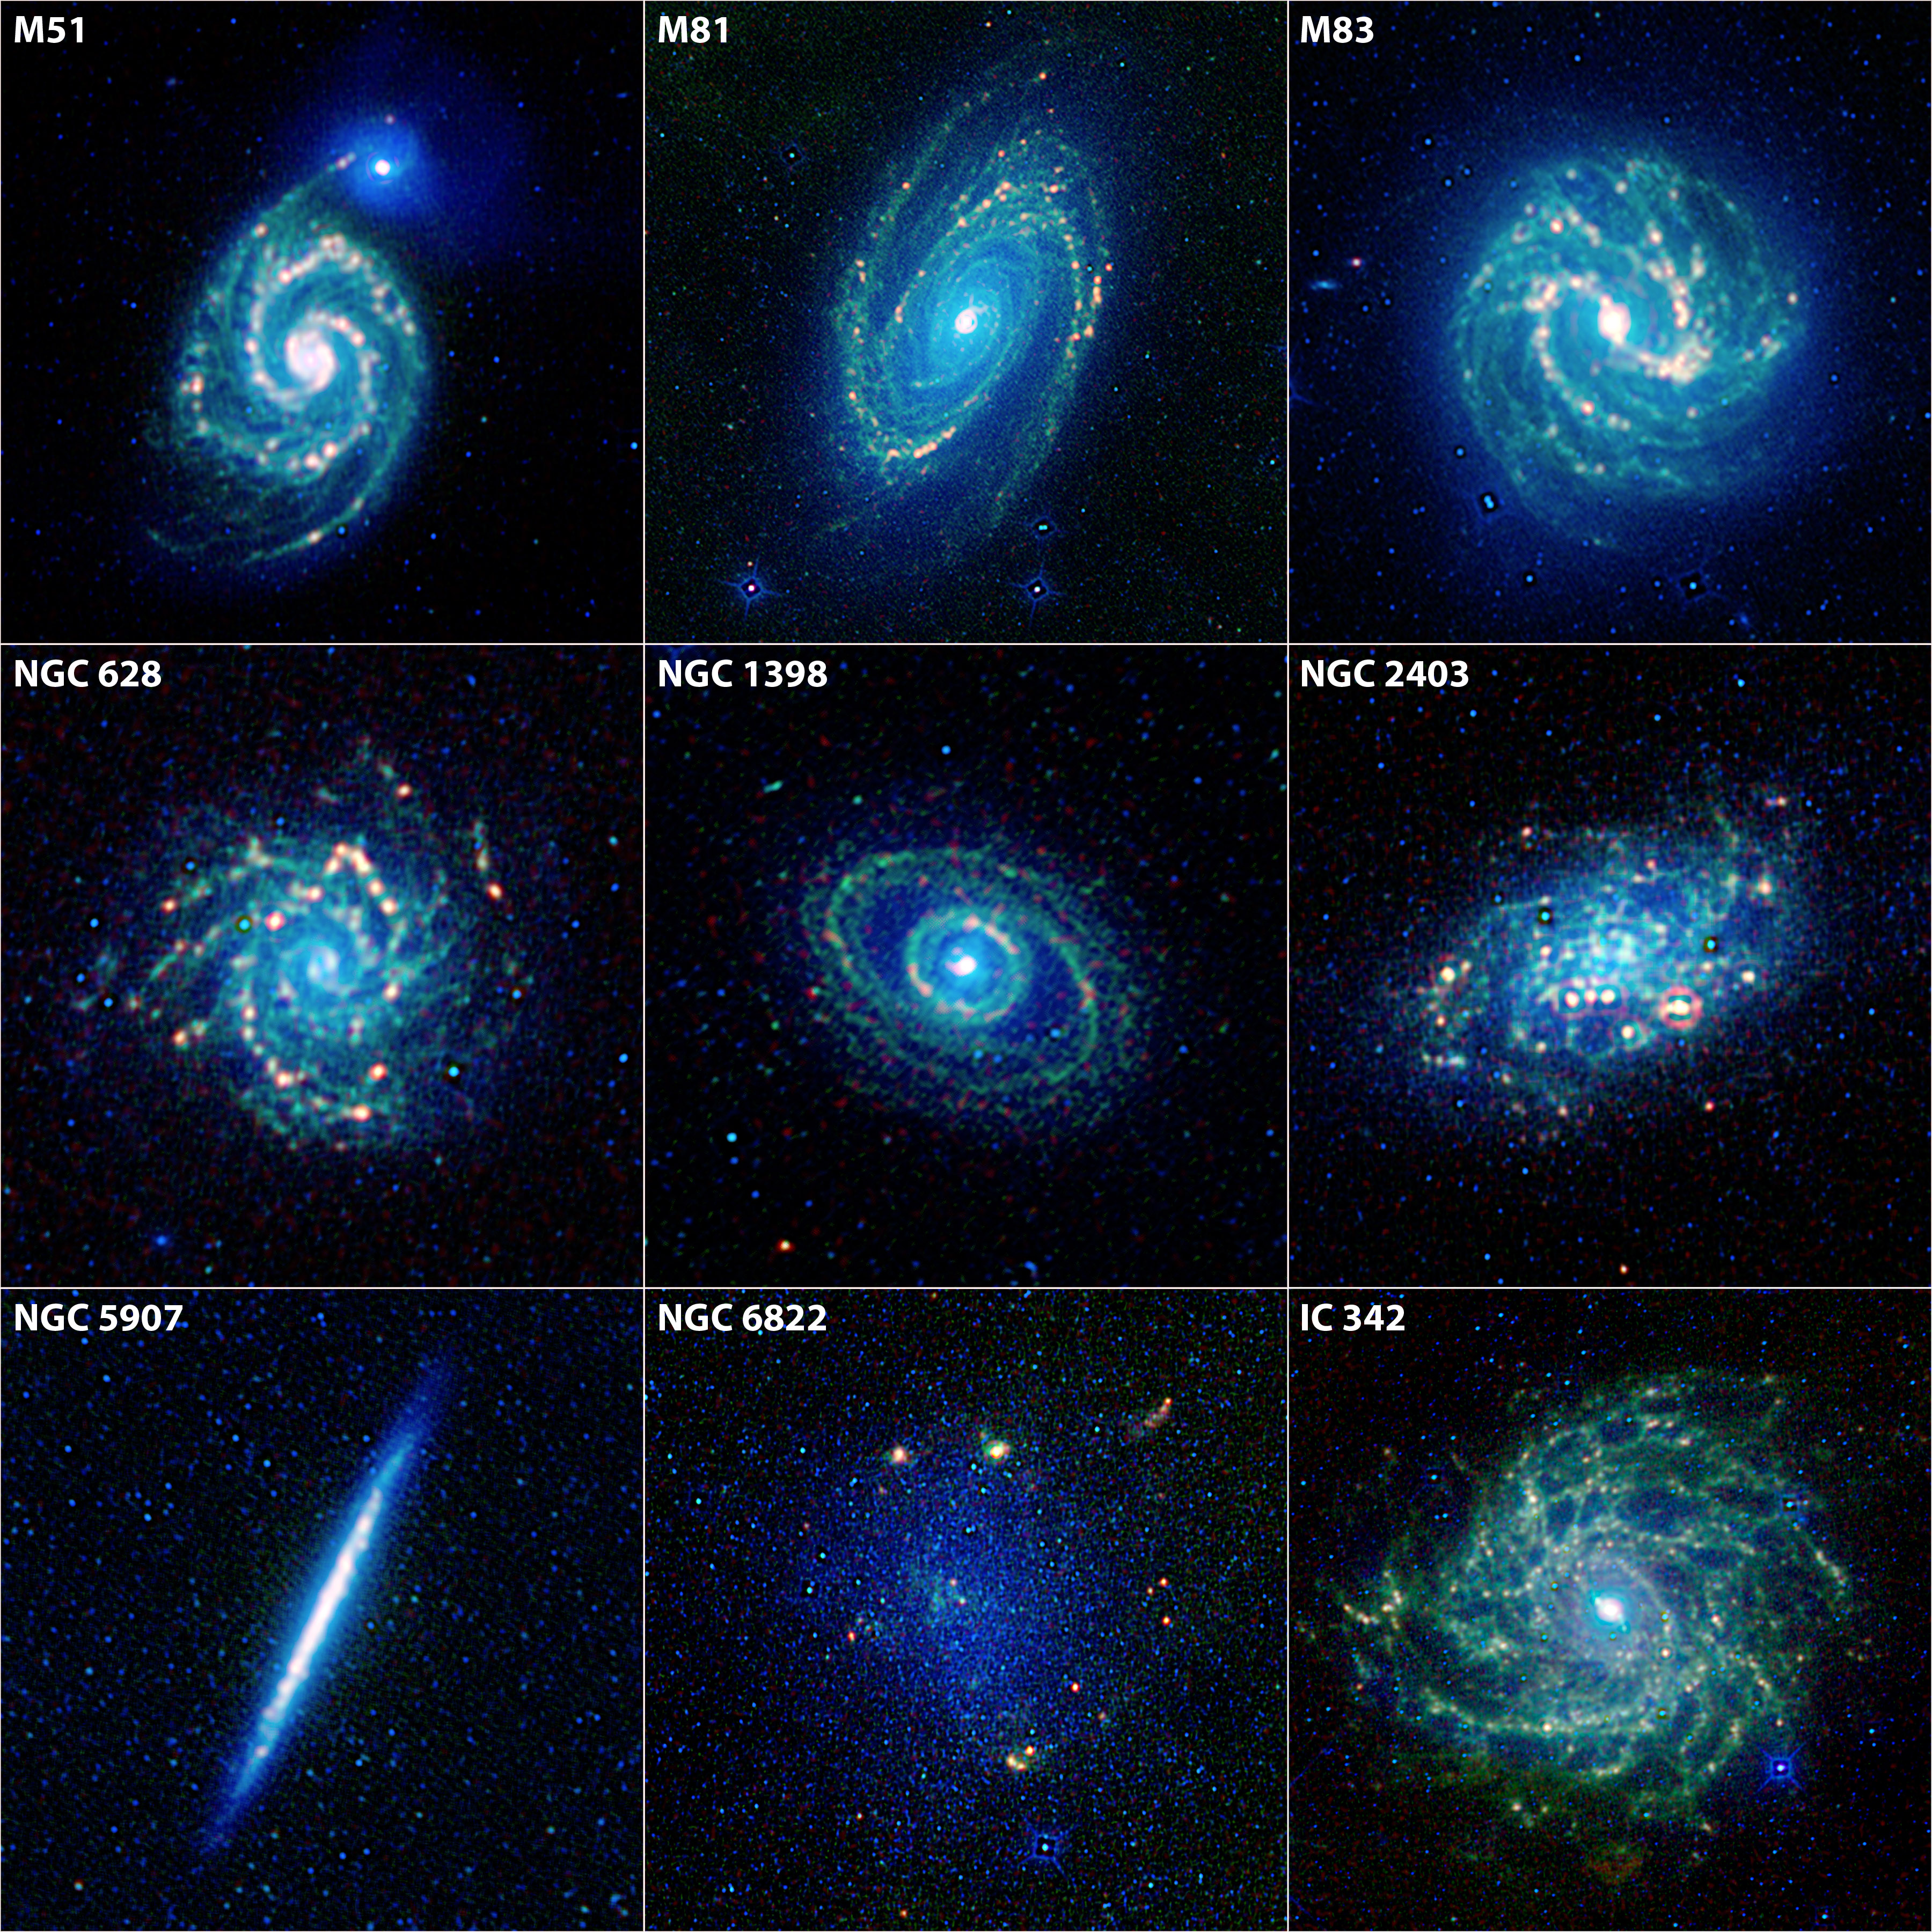

Planet

A planet is an astronomical object orbiting a star or stellar remnant that is massive enough to be rounded by its own gravity, is not massive enough to cause thermonuclear fusion, and has cleared its neighboring region of other objects. Planets are generally divided into two main types: large, low-density gas giants and smaller, rocky terrestrials.

Astronomers saw that, like Earth, the planets rotated around tilted axes, and some shared such features as ice caps and seasons. Since the dawn of the Space Age, close observation by space probes has found that Earth and the other planets share characteristics such as volcanism, hurricanes, tectonics, and even hydrology.

More than a thousand planets around other stars ("extrasolar planets" or "exoplanets") have been discovered in the Milky Way, ranging in size from Earth to gas giants larger than Jupiter. Around one in five Sun-like stars is thought to have an Earth-sized planet in its habitable zone.

The planets were originally seen by many early cultures as divine, or as emissaries of deities.

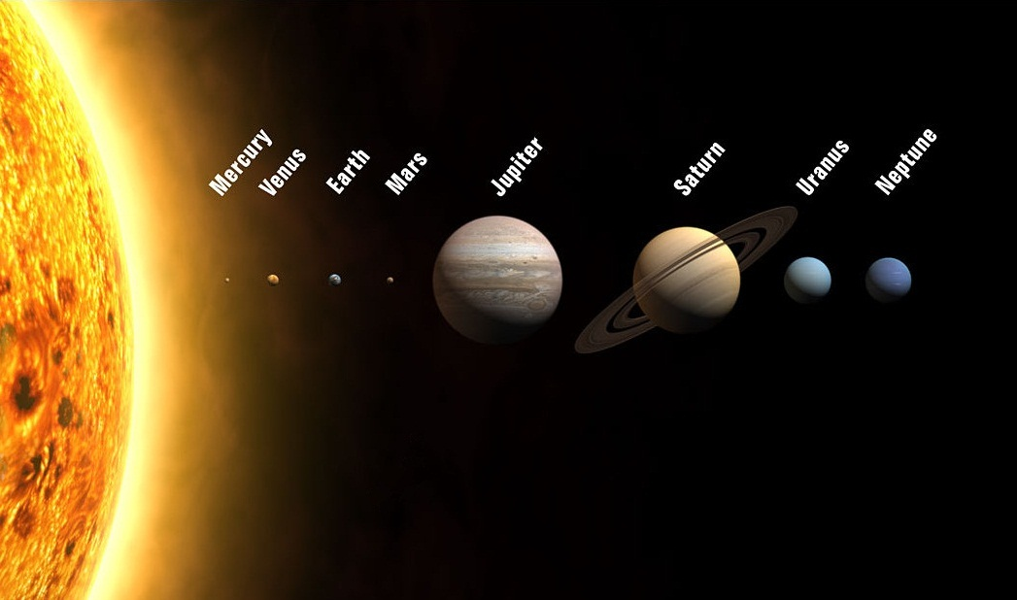

Stars

A star is a massive, luminous sphere of plasma held together by its own gravity. The nearest star to Earth is the Sun, which is the source of most of the planet's energy. Some other stars are visible from Earth during the night, appearing as a multitude of fixed luminous points due to their immense distance. Historically, the most prominent stars were grouped into constellations, and the brightest stars gained proper names.

For at least a portion of its life, a star shines due to thermonuclear fusion of hydrogen into helium in its core, releasing energy that traverses the star's interior and then radiates into outer space. Once the hydrogen in the core of a star is nearly exhausted, almost all naturally occurring elements heavier than helium are created by stellar nucleosynthesis during the star's lifetime and, for some stars, by supernova nucleosynthesis when it explodes.

The total mass of a star is the principal determinant of its evolution and eventual fate. Other characteristics of a star, including diameter and temperature, change over its life, while the star's environment affects its rotation and movement.

Stars are given a single-letter classification according to their spectra, ranging from type O, which are very hot, to M, which are so cool that molecules may form in their atmospheres.

Class | Temperature | Sample star
O | 33,000 K or more | Zeta Ophiuchi
B | 10,500–30,000 K | Rigel
A | 7,500–10,000 K | Altair
F | 6,000–7,200 K | Procyon A
G | 5,500–6,000 K | Sun
K | 4,000–5,250 K | Epsilon Indi
M | 2,600–3,850 K | Proxima Centauri

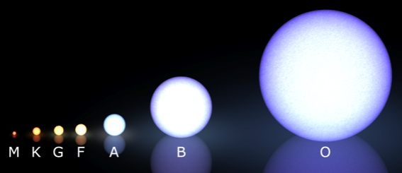

Star clusters

Star clusters or star clouds are groups of stars. Two types of star clusters can be distinguished.

Globular clusters are tight groups of hundreds of thousands of very old stars which are gravitationally bound, while open clusters, more loosely clustered groups of stars, generally contain fewer than a few hundred members, and are often very young.

Open clusters become disrupted over time by the gravitational influence of giant molecular clouds as they move through the galaxy, but cluster members will continue to move in broadly the same direction through space even though they are no longer gravitationally bound; they are then known as a stellar association, sometimes also referred to as a moving group.

