ACES Teacher Professional Development Application

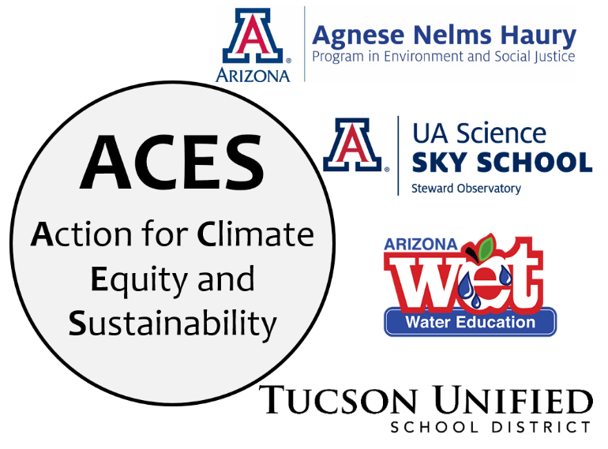
The ACES Teacher Professional Development program is a partnership between TUSD and UA Sky School to offer teachers an opportunity to build both content and pedagogy skills related to science education in general, and climate change and sustainability specifically. You'll deepen your understanding of climate change and related environmental challenges, with a focus on the effects in Tucson and Southern Arizona, and the associated social justice issues created or worsened by climate disruption. You'll be supported to create engaging science lessons and use PBL strategies to spearhead a student-driven sustainability project in the spring in order to impact the school or wider community.
Benefits:
- Gain a solid understanding of the 2018 Arizona Science Standards and how to implement 3D teaching
- Be supported to develop engaging science lessons that incorporate reading, writing, and math
- Utilize place-based teaching and a social justice focus to build relevance to your students' lives
- Learn about large-scale and local climate issues from researchers at UArizona and local organizations
- Connect with education and community leaders
- Paid professional development ($25/hour for all workshops) and up to 50 hours toward recertification
Commitment:
- Attend 9 online half-day Saturday workshops (9 am – 12:15 pm) from September to April and complete all associated work (~1.5 hours per workshop; we use Google Classroom). Each workshop will include a session focusing on science content, and another session on STEM pedagogy.
  - September 18
  - October 23
  - November 20
  - December 11
  - January 22
  - February 19
  - March 26
  - April 23
  - May 7
- Attend up to 3 in person, outdoor field excursions for hands-on learning: November 6, December 4, and February 5, with a make-up day on March 5 in case of inclement weather any of the other days
- Implement science lessons in your classroom that you develop during the workshops
- Lead a sustainability project developed with your students to benefit your school or local community
- Share your lessons and project with other educators and the community
ACES Teacher Professional Development Application
Please provide the following contact information:
Your Name: __________________________________________________________
Grade level/subject(s): __________________________________________________
Work #: _______________________ Cell or home #: ____________________
Email preferred for communication: ________________________________________
School name: _________________________________________________________
School Address: _______________________________________________________
Is this a Title I school? ______ Yes ______ No

Briefly answer the following questions:
- What science classes or topics will you teach throughout the year?

- Describe your school. Include student demographics, special characteristics, and relevant programs.

- What would you like to get out of this professional development opportunity?

- What benefits do you see for your students?

- Are there other teachers at your site applying that you would like to work with? If so, please provide their name(s) and grade level(s).

Commitment to participate:
I agree to participate in the ACES Teacher Professional Development program for the 2021-22 school year. I will participate in all ACES activities, as outlined in the above application materials. I understand that I will only be paid and awarded PD credit for the hours completed with ACES.
________________________________________ ______________________
Applicant Signature Date

________________________________________ ______________________
Principal Signature Date

Send your completed materials (pages 2 & 3) to UASkySchool@gmail.com

